**HBS Open Orders:** The HBS Open Orders tab is the first screen that appears when you open CNH Connect (CSPS). It displays all open CNH parts orders made in the HBS NetView parts ordering programs and allows you to send orders to CNH for verification before submitting them for processing.

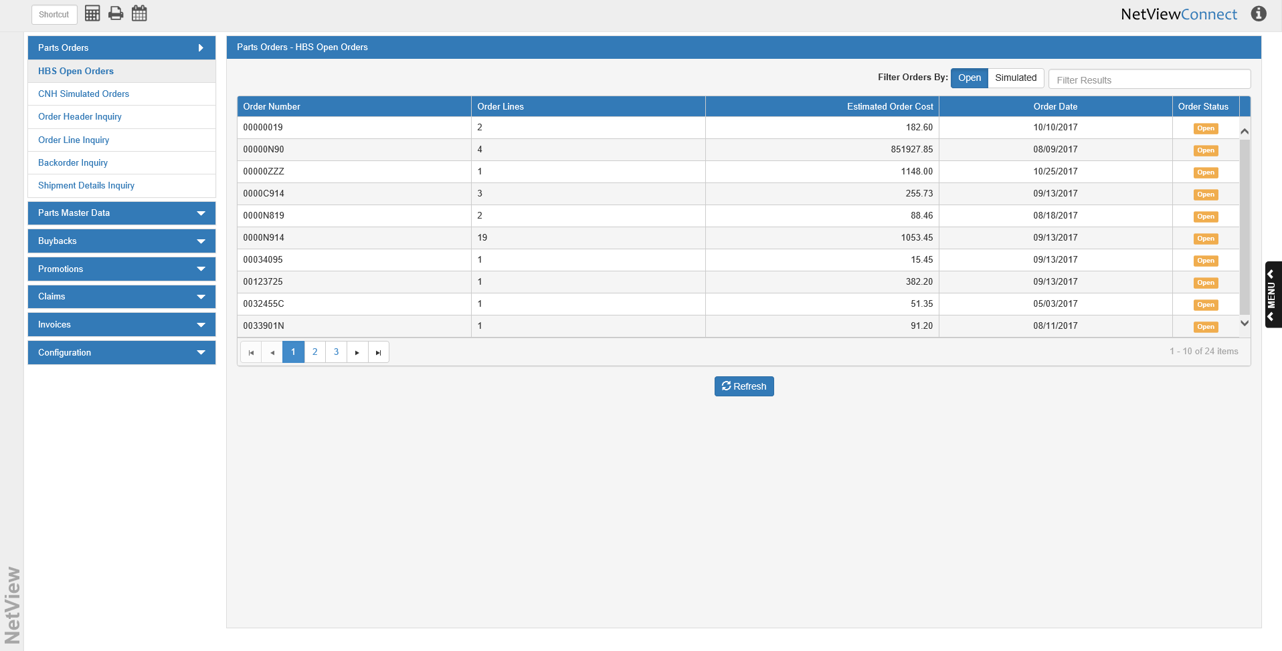

You can sort the orders by clicking on the column headers (once for ascending/alphabetic order, twice for descending/reverse-alpha order). You can also filter the list by entering characters into the **Filter Results** field; the list will then only show orders that contain the characters you typed in.

**Filter Orders By:** Use these options to change what orders are visible in the list. The default view is **Open**.

* Click **Open** to view all open orders that have not yet been verified.
* Click **Simulated** to see all orders that have been verified and submitted to CNH for processing, but have not be closed yet (see image example below).

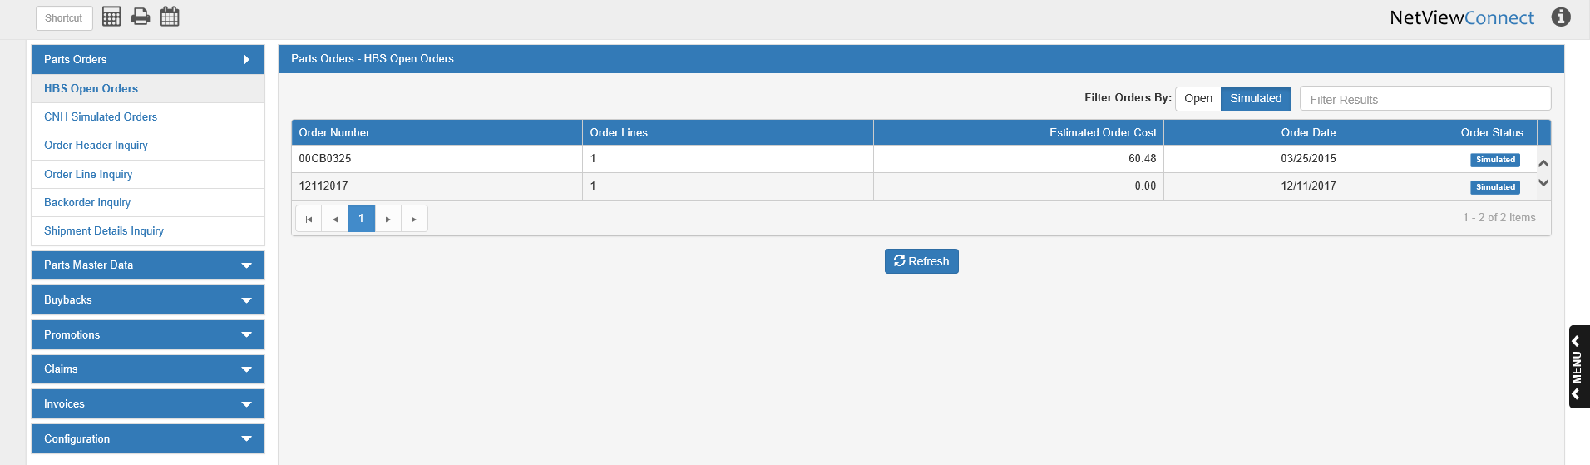

**Column Definitions:**

Order Number: This column shows the order number.

Order Lines: This column shows the number of lines on the order.

Order Cost: This column shows the order cost.

Order Date: This column shows the order’s creation date.

Order Status: This column shows the order’s status, which will be “Open” or “Simulated” depending on the filter applied. The default filter will only show orders with the “Open” status.

**Refresh:** Click this button to update the list. It will add any new orders to the list that have been made since the last refresh. If you have the Simulated filter on, clicking “Refresh” will reset the filter to **Open**.

**Editing Open Orders:** To edit an open order in CSPS, click on the order’s entry in the grid. If you do this with an order that has already been sent for verification, you will receive the following warning:

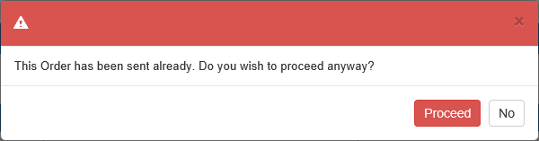

Click **Proceed** to edit the order anyway. **NOTE:** We **do not** recommend that you edit a Simulated order in this tab.

Once you select an order, the following window will open, showing the order details:

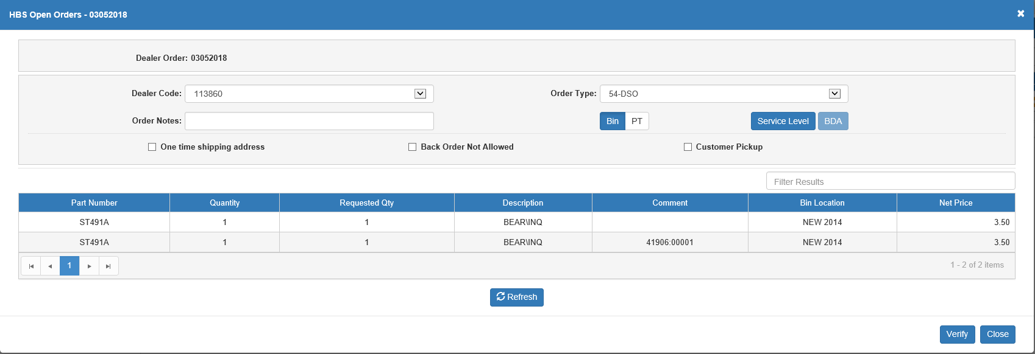

Use this screen to set the final CNH-specific details and send the order to CNH for verification.

Dealer Order: This field shows the dealer-assigned order number.

Dealer Code: This field sets the dealer’s CNH code for the order. This is mainly applicable if the dealer has more than one CNH code.

Order Type: This field sets the CNH order type. Select the desired type from the drop-down menu. **NOTE:** These types will not be available if you have not loaded them from CNH (see **Order Types** for more information).

Order Notes: Enter any notes you wish to include on the order in this field.

Bin/PT: If the Comment column for a part shows the picking ticket number and customer number in the same format as in the above image (PT;Cust), you can select **PT** to have them print on the order slip in place of the bin location. Leave **Bin** selected to have the bin location print.

Service Level: Click this button to view and manage the order’s service levels by warehouse. **NOTE:** No levels will be available to you if you have not loaded them from CNH (see **Service Level List** for more information).

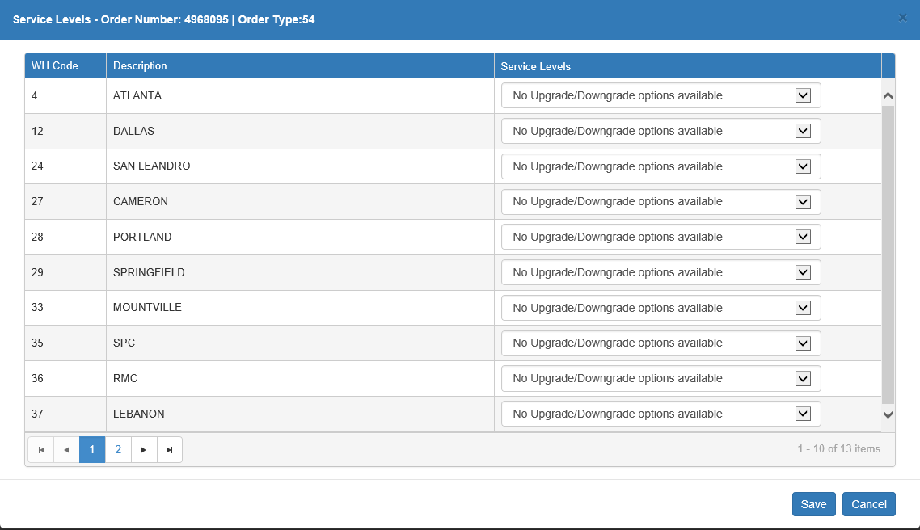

**WH Code:** This column holds the CNH warehouse code.

**Description:** This column holds the warehouse description, typically the name of the city where it is located.

**Service Levels**: Use the drop-down menus in this column to set the desired service levels for the warehouse, provided there are options available.

Click **Save** to save the levels and return to the order details.

BDA: If you make this order a type 50-BDA, then this button will activate.



Click on it to open the BDA Details window for the order. You **must** fill in these details in order to submit the order to CNH for verification. All required fields are noted in their descriptions.

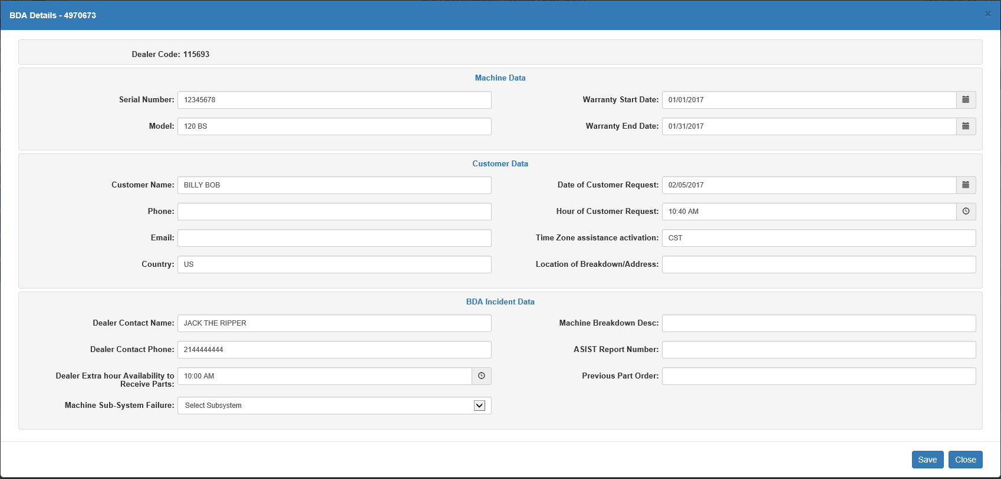

**Dealer Code:** This field shows the dealer’s CNH code as used on this order.

**Machine Data Fields**

* **Serial Number:** This field holds the serial number for the unit tied to the order. This is a **required** field.
* **Model:** This field holds the unit’s model number. This is a **required** field.
* **Warranty Start Date:** This field holds the unity’s warranty start date. Either type the date in or select it from the calendar. This is a **required** field.
* **Warranty End Date:** This field holds the unity’s warranty end date. Either type the date in or select it from the calendar. This is a **required** field.

**Customer Data Fields**

* **Customer Name:** This field holds the order’s customer name. This is a **required** field.
* **Phone:** This field holds the customer’s phone number.
* **Email:** This field holds the customer’s email address.
* **Country:** This field holds the customer’s country of location/residence.
* **Date of Customer Request:** This field holds the date of the customer’s BDA request. Either type the date in or select it from the calendar. This is a **required** field.
* **Hour of Customer Request:** This field holds the hour of the customer’s BDA request. Either type the time in or selecting it using the time picking feature. This is a **required** field.
* **Time Zone assistance activation:** This field holds the time zone in which the breakdown occurred.
* **Location of Breakdown/Address:** This field holds the location or address where the breakdown occurred.

**BDA Incident Data Fields**

* **Dealer Contact Name:** This field holds the dealer contact’s name for this order.
* **Dealer Contact Phone:** This field holds the dealer contact’s phone number.
* **Dealer Extra hour Availability to Receive Parts:** This field indicates a time outside of the dealer’s regular hours in which they would be available to receive a part delivery.
* **Machine Sub-System Failure:** This field indicates the CNH BDA subsystem code that best fits the breakdown.
* **Machine Breakdown Desc:** This field holds a description of the breakdown.
* **ASIST Report Number:** This field holds the order’s ASIST report number.
* **Previous Part Order:** This field holds the previous order number for the requested part(s).

One time shipping address: This field indicates whether or not this order will go to a one-time shipping address or the dealer’s default address. If the box is checked, then the following fields will appear, and you **must** fill them in before sending your order for verification.

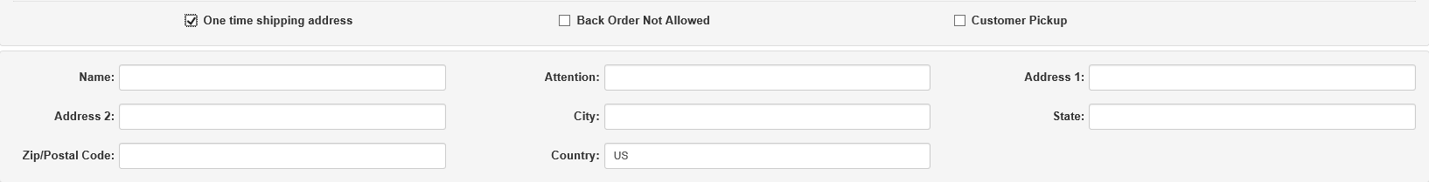

**Name:** This field holds the order recipient’s name.

**Attention:** If the address is for a large group or business, this field indicates

**Address 1:** This field holds the primary street address line.

**Address 2:** This field can hold a second address line, if required.

**City:** This field holds the city of the address.

**State:** This field holds the state or province abbreviation for the address.

**Zip/Postal Code:** This field holds the zip or postal code for the address.

**Country:** This field holds the country of the address. It will default to the dealer’s country.

**Address Lookup:** If you want to use a customer ship-to address saved in NetView for a one-time shipping address, click this button to open the Address Lookup.

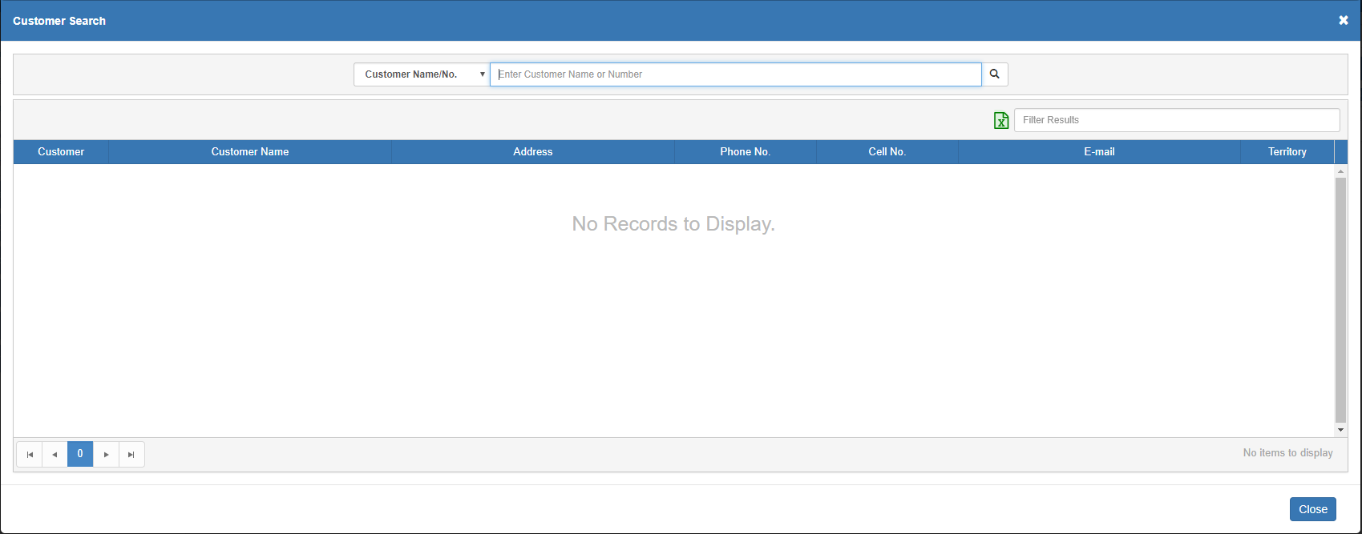

You can search for the address by Customer, Zip/Postal Code, Territory, City, Telephone, or Area Code. Choose your search method and type the search information into the field. **NOTE:** For the Telephone and Area Code searches, you must type in the full number; you cannot make a partial search for these two options (though you can for all other types).

Once you click “Search,” the screen will populate with all matching results:

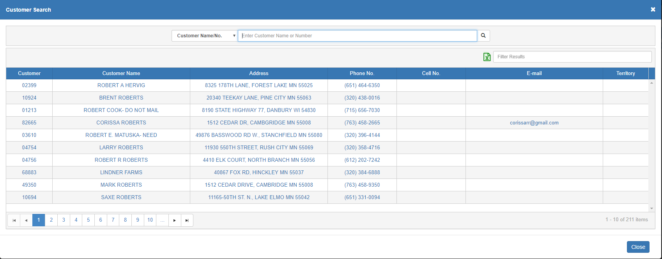

You can use the sortable header columns and the **Filter Results** field to locate your desired address. Once you click on the address, it will populate the one-time shipping address fields.

However, if the customer has more than one ship-to address recorded, the following will appear instead:

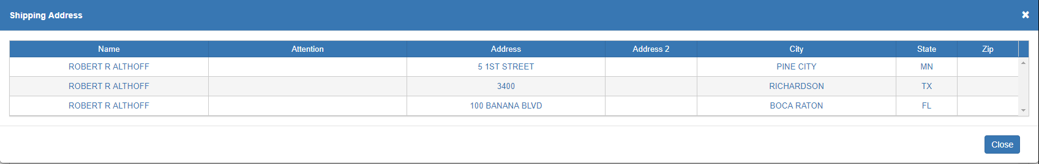

Click on the shipping address you want from the list to populate the OTS fields.

Back Order Not Allowed:

* Check this box to prevent CNH from placing any part of your order on back-order.
* Leave it unchecked to indicate that CNH can make a back-order for the parts on the order if necessary.

Customer Pickup:

* Check this box to indicate that you, as the dealer, will pick up your order from the CNH depot, rather than having it delivered to an address.
* Leave it unchecked to have CNH ship it directly to your address of choice.

Order Details Grid: The grid shows all lines on the order and their details. These lines can **not** be edited in CSPS; you will have to return to the NetView ordering programs to edit the order lines.

**Filter Results**: You can use this field to filter the detail lines by entering specific information. This works best with orders that have multiple pages of detail lines and you only want to see specific ones.

**Grid Columns:**

* **Part Number:** This column shows the part number for the line.
* **Quantity:** This column shows the quantity of the part currently listed on the order.
* **Requested Qty:** This column shows the quantity of the part that the dealer originally requested. In this screen, it should be identical to the value in the Quantity column; changes to the quantity only tend to occur after the order is verified.
* **Description:** This column holds the part’s description.
* **Comment:** This column holds any comments on the order line. If the picking ticket number and customer number are available to print on the order slip, they will show here in the format pictured above (PT;Cust).
* **Bin Location:** This column shows the part’s bin location for the dealer.
* **Net Price:** This column shows the part’s net price for a single unit.

Refresh: Click this button to update the order details to match any changes that have occurred in the NetView ordering programs since the details were opened for view.

Close: Click this button to close the window without sending the order for verification or saving your changes. If you have made any changes, particularly in the Service Level or BDA windows, and click this button, a warning message similar to the one below will appear:

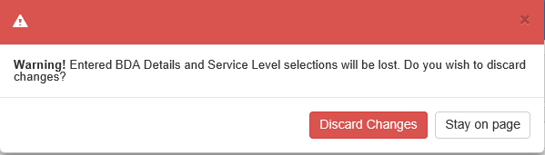

* Click **Discard Changes** to discard your changes and close the window.
* Click **Stay on page** to remain in the window and save your changes/send the order for verification (depending on what changes you made).

Verify: Click this button to send the order to CNH for verification. The screen will then load the order’s CNH Simulated Order Details window, showing the results of the verification.

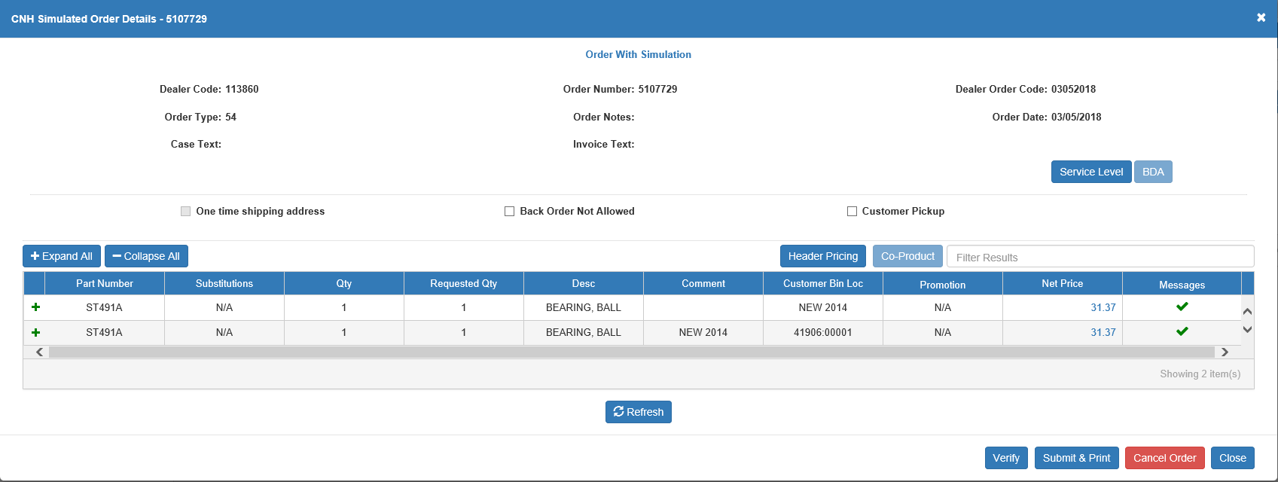

From this screen, you can re-verify the order, cancel its simulated status, or, if all the lines are correct (i.e. have no errors or warnings attached, as in the image above), submit it to CNH for processing and print the order details.

If there are errors or warnings, or you are simply not ready to submit the order yet, the order will now appear in the CNH Simulated Order tab, where you can view this screen at any time and make your submission at a later date. **NOTE:** if there are any warning or error messages on your order post-verification, you must address them before submitting the order to CNH.